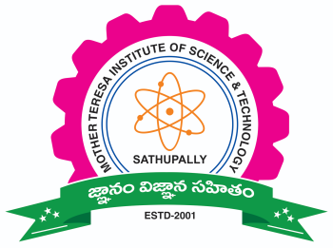
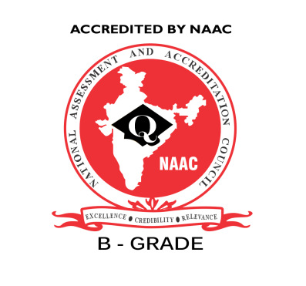
MOTHER TERESA
INSTITUTE OF SCIENCE AND TECHNOLOGY
Approved by AICTE, Govt. of Telangana ,Affiliated to JNTUH & SBTET, Hyderabad
Recognition under Section 2(f) & 12 (B) of the UGC Act, 1956
SANKETIKA NAGAR, KOTHURU (V), SATHUPALLY – 507303, KHAMMAM Dist., TELANGANA
Phone : 9494641251, Email ID : info@mistech.ac.in

DEPARTMENT OF ELECTRONICS AND COMMUNICATION ENGINEERING
ACADEMIC YEAR: 2018-19
A SUMMARY REPORT
Course name: Conducted a guest lecture on EM Waves and Applications

Name of the Resource Person: Dr. D.Dayakara Rao

Gap Identified: Required Knowledge on Spherical, cylindrical and Cartesian coordinate systems vector conversions

No. of Students attended: 37
Summary: On the day of the session (i.e 06-02-2019) Dr. D.Dayakara Rao delivered a lecture on, EM Waves and Applications. Electromagnetic waves are also known as EM waves. Electromagnetic radiations are composed of electromagnetic waves that are produced when an electric field comes in contact with the magnetic field. It can also be said that electromagnetic waves are the composition of oscillating electric and magnetic fields. Electromagnetic waves are solutions of Maxwell’s equations, which are the fundamental equations of electrodynamics.
Applications of Electromagnetic Waves
Following are a few applications of electromagnetic waves:
- Electromagnetic radiations can transmit energy in a vacuum or using no medium at all.
- Electromagnetic waves play an important role in communication technology.
- Electromagnetic waves are used in RADARS.
- UV rays are used to detect forged bank notes. Real banknotes don’t turn fluorescent under UV light.
- Infrared radiation is used for night vision and is used in security cameras.

